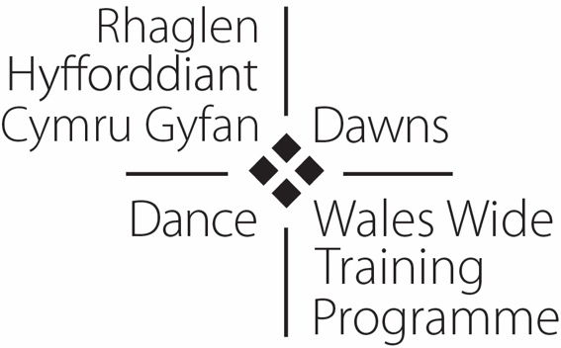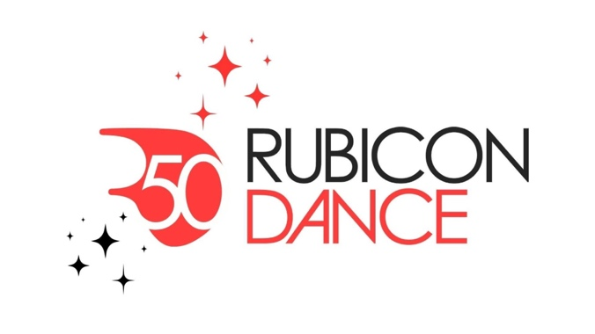

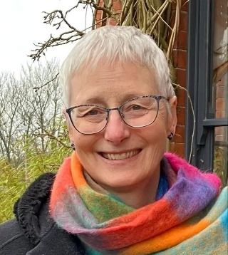
Wales Wide Training Programme
Case Study - Heidi Wilson
An Enduring Relationship: Wales Wide Training Programme and Me

This case study offers a personal reflection on the value of the Wales Wide Training Programme for dance (WWTP) to me as a freelance Community Dance Practitioner and as a Senior Lecturer in Dance at Cardiff Metropolitan University (.4). I begin with a focus on Dancing with Parkinson’s which is central to my practice and central to my ongoing relationship with WWTP.
Strictly Parkinson’s is 12 years old now. Some original members are still here, others have died but their partners remain, new friends have come along from time to time. Our knowledge of Parkinson’s has grown as together we navigate this chronic condition and discover what dance may have to offer. Learning from the work of others in the field we have created our own patchwork, piecing together what works for us. Discarding and adding as needs change dictated by Parkinson’s.
Our learning has been nurtured throughout this time by WWTP. By being noticed we feel seen and acknowledged. What we have and do is validated beyond our weekly group and our quiet, rural practice is now well recognised in Wales and much further afield (for example, input into People Dancing’s Summer Intensive). My understanding of this work has been deepened by the framing that WWTP strands have offered. Being invited to share my practice in various forms requires that I pause, reflect, read, question, ask, think, wonder, try, listen, notice, honour and discover. The termly cycle of WWTP Dance with Parkinson’s forums provide points in time where growth in practice is measured and ideas tested with colleagues in generous and safe discussions. A community of practice which draws participants from near and far, people who give me the courage to be brave in this challenging dance space. Some of this learning has found its way into blogs and the online publication Animated (see Autumn 2025) hosted by People Dancing.
My own training and mentoring needs have been supported by WWTP. Of considerable value has been time spent with Dr Sophia Hulbert learning about Parkinson’s Dance Science from her unique perspectives as a dancer and neuro-physiotherapist. This has led to an enduring professional partnership with opportunities to work together and design CPD training with WWTP and People Dancing. I have had the great privilege of mentoring dance practitioners emerging into the specialist field of dancing with Parkinson’s, including Francine Hills, Angharad Jones and Linzi Rumph. Their interest and inciteful questions and subsequent conversations have pushed me to reflect and deepen my understanding. Facilitated and funded by WWTP the model of ‘come and see’, join in, question and enquire always consolidated my own learning, whether I was going to share in someone else's practice (e.g. Cai Tomos) or they were coming to share in mine. These interactions push me to interrogate what we do and why. Prompting me to ask, ‘how might it be different’ and ‘could there be a better way’?
WWTP was an early adopter of Dance for Parkinson’s (now reframed as Dance with Parkinson’s to recognise the coproduction of this practice). In June 2016 WWTP ran the CPD day Dance and Music in Health including a DfP demonstration class led by myself and Rosie Hazell, hosted in Carmarthen by Arts Care/ Gofal Celf (ACGC). This was followed by rapid developments in Dance for Parkinson’s CPD offered by WWTP. In response to practitioner demand, the palette of CPD came to include in-person training days, bespoke mentoring and ‘go and see’ opportunities. This paved the way for our partnership with People Dancing (Kiki Gale) in the modification and delivery of their two-day course Introduction to Dance for Parkinson’s. This highly successful course was realised in June 2019 as a partnership between WWTP, Cardiff Metropolitan University and People Dancing. To meet the needs of the Welsh context, only experienced community dance practitioners were invited to apply. Bursaries were offered to make it affordable and follow-up opportunities were identified in the form of seed-funding for pilot DfP classes, on-going mentoring and termly DfP forum events. Workshop leaders included Wales-based practitioners - myself, Yvette Halfhide and Helen Woods from English National Ballet (ENB)/National Dance Company Wales (NDCWales) DfP programme, and Dr Sophia Hulbert (Parkinson’s Dance Science, Pavilion Dance South West and Cornwall). The wider context of arts and health framed the course with contributions by Baroness Kay Andrews OBE, Parkinson’s UK Cymru and Arts Council Wales. The course benefited from the recent publication of ACW’s Arts and Health in Wales: A mapping study of current activity (2018) authored by Sally Lewis, marking the wellspring of a sustained focus on the contribution of arts to the health of the nation.
Despite the impact of the Covid19 pandemic in 2020, DfP initiatives continued to develop as a direct result of the course. Angharad Jones (Theatr Clwyd) established her practice online with people with Parkinson’s attending from all over Wales and she continues to bring her unique perspective and approach to her classes. She, in turn, has mentored other practitioners to take on classes with Theatr Clwyd’s community engagement programme. The ENB/NDCWales partnership endures with additional classes in northwest and northeast Wales complementing those in Cardiff and Bridgend. These practitioners are also active members of WWTP and contribute to and attend DwP forum events and CPD. The community of practice feels strong and vibrant, despite the current challenges facing the dance sector.
“I was so nervous about my first session back and her reflection and perspective, and discussion really helped me. And her little practical session was so useful too, just a different take on things. What a woman!” (participant comment)
In addition to the Dancing with Parkinson’s strand of WWTP which remains consistent, I have benefited through countless other WWTP strands. The development of online events necessitated during the pandemic has opened up an impressive range of ‘bite size’ events. Usually no more than one hour in length, these can often be accommodated into my working day and provide a vital way to keep informed and in contact with colleagues. These have included: presentations about work by companies including Stopgap Dance Company, Ballet Cymru, Fallen Angels Dance Theatre, Hijinx, Humans Move (to name a few); inspirational speakers, and; thematic CPD such as early years, dance and health, access and inclusion and dance in education. On occasion, my Dance Pathway students from Cardiff Metropolitan University have been able to join both in person and online CPD significantly deepening their understanding of community dance and providing valuable networking opportunities. Some of these students have gone on to seek work placements with WWTP partners and to work in the community dance sector in Wales. Bespoke CPD for new graduates is an important feature of WWTP and can provide a stepping stone from education into employment.
The soft skills that cushion effective community dance practice need acknowledging and nurturing. The emotional landscapes in which we work can be challenging and keeping yourself well is essential. One-to-one Creative Practice Support Sessions with Cai Tomos have been a huge support to me as I have navigated difficult and emotionally charged situations. This affordable and high-quality support is invaluable to a freelance workforce who often feel isolated and are unsure where to turn. Tracey Brown is deeply committed to supporting the practitioners who make up the WWTP database and always ensures CPD is designed in response to expressed need. This makes the programme relevant and meaningful and lies at the centre of its success.
As well as the practice-based CPD, additional skills essential to survival in the sector are offered. I have benefited tremendously from business support and understanding evaluation sessions with Dr Susanne Burns. Her clarity, contextual understanding and ‘know-how’ have deepened my understanding and effectiveness. Affordable access to her skill, expertise and sensitive support has been invaluable.
WWTP has been an important platform through which to develop my skills as a trainer and facilitator, also providing a valuable income stream. This has included in person CPD, guiding online forums and discussions, presenting research findings and supporting reflective practice. Most recently, I had the privilege to lead A Time to Pause for WWTP at the National Botanic Gardens of Wales (24th April 2026). Hosted by Arts Care Gofal Celf, this was a gathering of community dance practitioners from across Wales who came together to dance, laugh and generously reflect on the challenges and rewards of long-term community practice. I realised how important these people are to me and what a huge resource Wales has in these remarkable dance practitioners whose dance skills frame the deep humanity they bring to their work. One participant comment, "Chilled, relaxed, reflective day, sharing with others our thoughts about our practice. Thanks, Heidi, for your guided reflections".
WWTP keeps us going, brings us together, challenges us, values us and looks after us. Thank you! Without WWTP, community dance as a freelancer would be at risk of stagnation and be a very lonely place indeed.
Heidi Wilson
May 2026

